Develop MetaFabric Back end 3
Follow this: https://chatgpt.com/g/g-p-6adb70a301b881918f3573c2e283e8be-meta-ai-competition/c/6ae68ab3-4c48-83ea-82b1-5c340da208a8

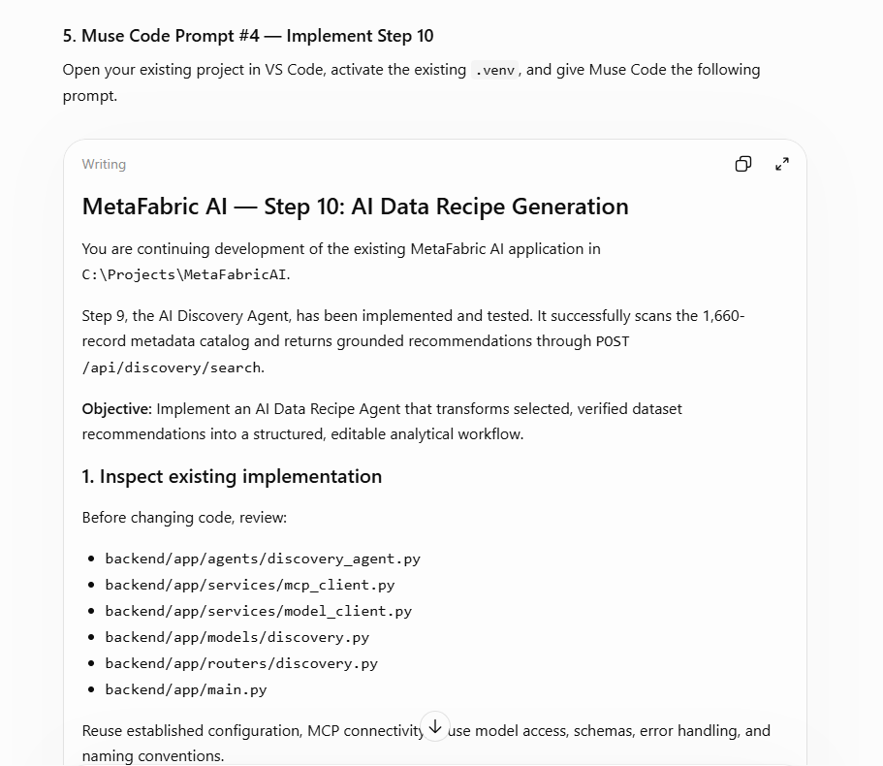

Student wants: no way to confirm if Prompt is pasted correctly.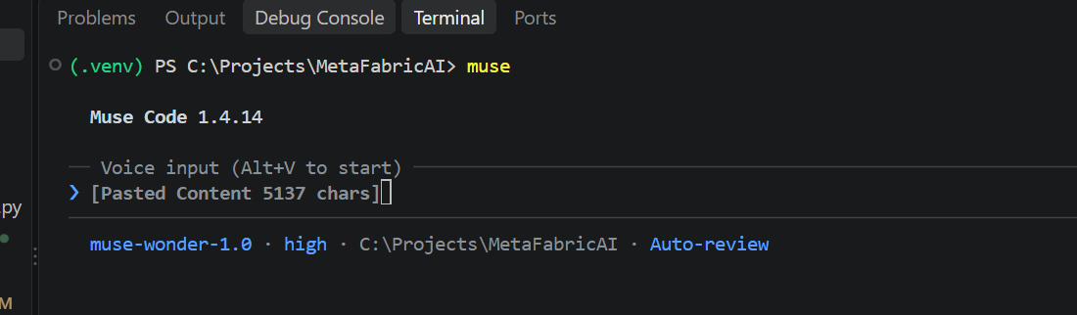

◆ Step 10 is implemented and verified. Step 9 remains intact.

Files created

• /C:/Projects/MetaFabricAI/backend/app/models/recipe.py — request/response models, internal
RecipeDraft, workflow/relationship models
• /C:/Projects/MetaFabricAI/backend/app/agents/recipe_agent.py — RecipeAgent /
DataRecipeAgent
• /C:/Projects/MetaFabricAI/backend/app/routers/recipe.py — POST /api/recipe/generate
• /C:/Projects/MetaFabricAI/backend/tests/test_recipe.py — mocked MCP + model tests

Files modified

• /C:/Projects/MetaFabricAI/backend/app/main.py:11 — registers the recipe router under /api
• /C:/Projects/MetaFabricAI/backend/app/config.py — adds recipe_max_completion_tokens
(default 8192, env RECIPE_MAX_COMPLETION_TOKENS)
• /C:/Projects/MetaFabricAI/backend/app/models/__init__.py,
/C:/Projects/MetaFabricAI/backend/app/agents/__init__.py,
/C:/Projects/MetaFabricAI/backend/.env.example, /C:/Projects/MetaFabricAI/backend/README.md

How it works

Selection is validated (nonempty, no blanks, no duplicates, max 20), then verified with
exactly one get_layer_metadata(layer_ids=[...]) call using its discovered schema — no catalog
rescan. Unknown IDs fail before any model call.

Server builds dataset identities/metadata from MCP records. Muse Spark (default
muse-spark-1.3, strict JSON Schema via the existing model client) only proposes roles,
relationships, and steps. Model-invented AssignedIDs and forward/cyclic step references are
dropped with warnings. Steps are renumbered to stable step-1, step-2, … with remapped
input_step_ids, so the JSON supports a connected-node diagram, dataset add/remove, step
editing, and regeneration.

Relationships carry basis: metadata_supported or proposed_requires_verification (with
verification_needed). Metadata-derived gaps (missing title/description/extent/access URL) are
added to data_gaps.

Final schemas

Request POST /api/recipe/generate:

{
"question": "string, 3-2000 chars (required)",
"selected_assigned_ids": ["42", "7"],
"location": "optional string",
"discovery_context": {
"interpreted_intent": "optional",
"location": "optional",
"dataset_context": [{"AssignedID": "42", "relevance_reason": "...", "proposed_role": ".
.."}]
}
}

AssignedIDs, assigned_ids, selected_dataset_ids, and similar aliases are also accepted.

Response:

{
"recipe_id": "uuid",
"question": "...",
"analytical_objective": "...",
"status": "proposed_not_executed",
"analysis_performed": false,
"selected_datasets": [{"AssignedID": "42", "title": "...", "description": "...",
"source_portal": "...", "access_url": "...", "tags": "...", "extent": "...",
"role": "...", "role_explanation": "...", "relevance_reason": "...",
"limitations": [], "metadata": {}}],
"relationships": [{"relationship_id": "rel-1", "source_dataset_id": "42",
"target_dataset_id": "7", "relationship_type": "spatial_overlay",
"description": "...", "basis": "proposed_requires_verification",
"verification_needed": ["geometry", "coordinate system"]}],
"workflow_steps": [{"step_id": "step-1", "order": 1, "operation": "load_datasets",
"title": "...", "explanation": "...", "input_dataset_ids": ["42", "7"],
"input_step_ids": [], "proposed_output": "..."}],
"expected_outputs": [], "data_gaps": [], "assumptions": [],
"limitations": [], "uncertainties": [], "warnings": []
}

Errors: 422 invalid_recipe_request (empty/duplicate), 404 dataset_not_found,
503 model_not_configured / mcp_unavailable, 502 model_error. No credentials are exposed.

PowerShell examples

cd C:\Projects\MetaFabricAI\backend
..\.venv\Scripts\Activate.ps1
python -m uvicorn app.main:app --reload --host 127.0.0.1 --port 8000

$body = @{
question = "Which neighborhoods in Washington, DC are vulnerable to flooding?"
selected_assigned_ids = @("42", "7")
location = "Washington, DC"
} | ConvertTo-Json

Invoke-RestMethod -Method Post -Uri http://127.0.0.1:8000/api/recipe/generate `
-ContentType "application/json" -Body $body

# Unknown ID -> 404; duplicates -> 422
python -m pytest tests -v

Test results

Full backend suite: 78 passed, 1 skipped (live opt-in test). The recipe + discovery subset
re-run after the final edits: 60 passed, 1 skipped. The strict JSON Schema conversion for
RecipeDraft was also verified directly (additionalProperties: false, all fields required).

Coverage includes single/multiple datasets, duplicates, empty/blank IDs, missing IDs (404,
model never called), MCP failure (503), model provider/malformed/no-steps failures (502),
verified-metadata and selection-order preservation, invented-ID dropping, stable step
references, no catalog rescan, and proposed_not_executed / analysis_performed: false.

Remaining issues: none. No Azure deployment, no MCP server changes, no new virtual
environment, and no frontend work in this step.

◆ Worked for 5m 29s · 8:58 PM · 31/Oct

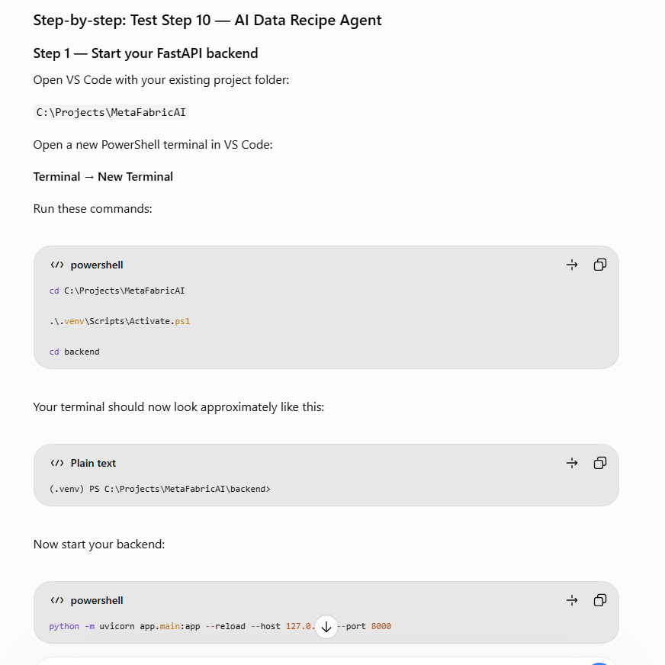

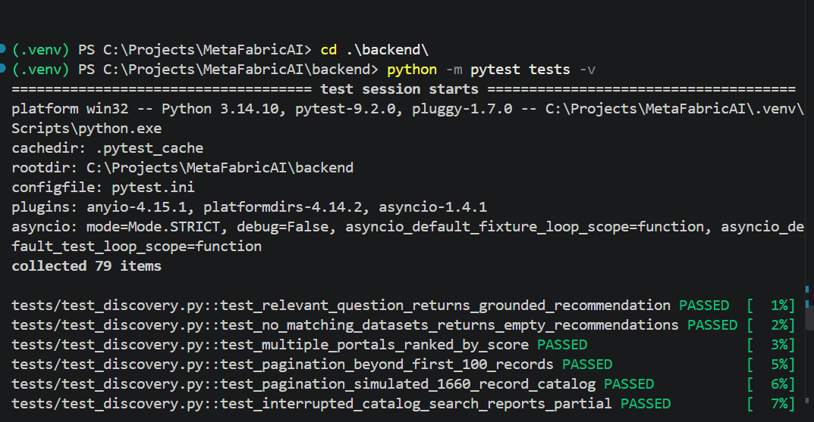

Check in the code to GIT


